Reflection for June 21 – Proper 7
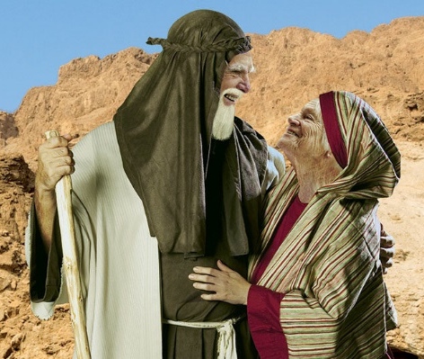
This past Sunday, we began to look at the stories of Abraham and Sarah as found in the book of Genesis. Abraham is critical to the building block of our Christian faith, and, Abraham is also a prominent figure for our Jewish and Muslim brothers and sisters.
All three major religions contain stories of Abraham and Sarah and these stories help the faithful to engage in the evolution of humanity’s understanding of the one God who created us and defines the ways in which we worship and understand our past.
We understand that the stories of scripture were written down after centuries of surviving in the oral traditions of the times. Stories which spoke the truths about humanity and their relationship with God even when they might not be factual.
The stories of scripture tell us about Adam and Eve and their failure to follow God’s command which leads to their expulsion from the Garden of Eden. We hear about Noah and his family, apparently the one faithful family who are saved by God from the floods which covered the known world.
And then we hear the story of the Tower of Babel as people sought to ignore the words of God the Creator and seek their own power and success. And then, we begin to hear the stories of Abram, a man who heard the call of God and responded in faith.
We began by looking at the initial call of Abram – this came at a time when God was largely unknown. Abram was an important part of his family business. He and his wife Sarai were childless, and lived with Terah, Abram’s father and extended family. It is understood (those not stated in scripture but understood to be true by Jewish scholars) that Terah was a seller of idols of many kinds.
Abram was a shepherd, and at the age of 75 left it all behind to begin a journey in response to the call of God. (based on Genesis 12) It must have been something like a parade as they travelled with all of their possessions – sheep and goats, camels, servants and slaves, food and water!
We heard the stories of Abram, Sarai and their nephew Lot as they journeyed toward Hebron where he built an altar to honour God. And later, God reiterates the promise made to Abram that: I’ll make you a great nation and bless you. I’ll make you famous;
you’ll be a blessing. I’ll bless those who bless you; those who curse you I’ll curse. All the families of the Earth will be blessed through you.”
Together we explored that stories of Sarai’s impatience and then her jealously as her clever plan seemed to take a wrong turn. Sarai wanted her husband to have an heir and she decided that her Egyptian slave Hagar would be the perfect surrogate mother. And yet, when Hagar became pregnant, Sarai felt threatened and sent Hagar into the wilderness—alone and with little or no food and water.
Once again, we hear the story of how God intervened and Hagar returned to the camp and in time gave birth to her son who was welcomed by Abram who became a father at the age of 86. Abram named the baby Ishmael in fulfillment of God’s promise to Hagar.
This coming week, we will explore the importance of our names as we hear the story of God renaming Abram and Sarai. We hear the promise of God that Abram would be the father of a great nation one more time – and both Abram and Sarai have a hard time believing in the promise – after all, Abram is 99 and Sarai herself is well past the normal child-bearing age.
You might be asking … why are we looking at these stories? What can they say to us as we live in a very different world from that of Abram and Sarai.
I believe that even while our world may look different, what has not changed is the ability of people to mistrust each other, to use one another for personal advantage and to forget that God is with each of us even when we are unclear or uncertain about the future.
Each of us knows that since the middle of March, our world has been turned upside down. We have come face to face with the realities of a world pandemic. We have followed the rules. We have stayed home. We have learned to practice social distancing. And we are reminded constantly to wash our hands.
While some are anxious to return to the ways of our previous lives, most of us are reconciled to this new way of living – a new way of being in community with one another.
And as a church community, we are learning and experimenting with new ways to gather for worship, for study and for connection with one another.
As you find new ways to celebrate Fathers’ Day, may you be surrounded with love and filled with hope.!
May God be with us, in our new practices.
May Jesus teach us to walk with humility and with compassion.
And may God’s Holy Spirit continue to welcome us with love and joy and laughter.
May blessings rest on each of you!

Rev. Mary Best

